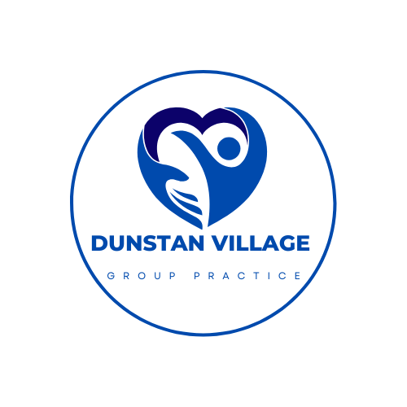

JOIN THE DUNSTAN VILLAGE GROUP PRACTICE PATIENT PARTICIPATION GROUP!

Are you interested in finding out more about the practice?

Would you like to influence the development of health services locally?

If the answer is YES, have you ever thought about joining the Dunstan Village Group Practice PPG?

Dunstan Village Group Practice PPG is actively seeking patients to join our meetings.

We are keen to hear from people of all backgrounds, ages and gender, to attend our regular quarterly meetings.

The PPG is run by volunteer patients, and practice staff to help strengthen the relationship between the practice and you, their patients. The PPG contributes ideas feedback and suggestions to the practice to improve the patient experience

If this is something you may be interested in, or would like more information, please contact: 0151 734 3535

